Chapter 8, Solution 15.

Given that s₁ = -10 and s₂ = -20, we recall that

s_{1,2} = 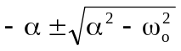 = -10, -20

Clearly, s₁ + s₂ = -2α = -30 or α = 15 = R/(2L) or R = 60L (1)

s₁ = 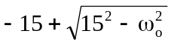 = -10 which leads to 15² – ω_{o}² = 25

or ω_{o} = 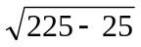 = 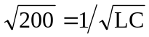, thus LC = 1/200 (2)

Since we have a series RLC circuit, i_{L} = i_{C} = Cdv_{C}/dt which gives,

i_{L}/C = dv_{C}/dt = [200e^{-20t} – 300e^{-30t}] or i_{L} = 100C[2e^{-20t} – 3e^{-30t}]

But, i is also = 20{[2e^{-20t} – 3e^{-30t}]x10⁻³} = 100C[2e^{-20t} – 3e^{-30t}]

Therefore, C = (0.02/10²) = 200 μF

L = 1/(200C) = 25 H

R = 30L = 750 ohms

